Personal Information

Applicant Name : **IRFAN SHEIKH**

CNIC No. **35202-0315367-3**

Father's Name : **SHEIKH ASHFAQ AHMAD**

Gender **Male**

Date of Birth : **10/02/1986**

Domicile District : **Lahore**

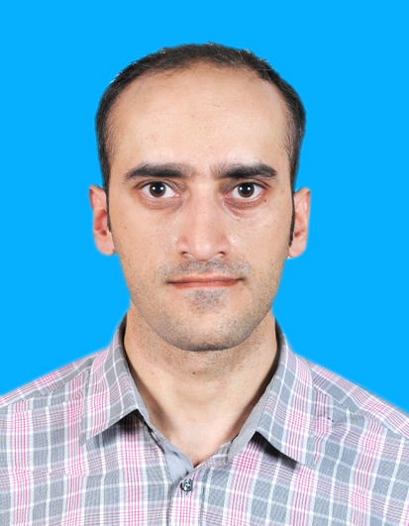

Contact Information

Email Address :  **S4SHEIKH@LIVE.COM**

Mobile No.  **03214881890**

Secondary Contact No.

Permanent Address :  **SUITE#6, 2ND FLOOR, COMMERCIAL ZONE, LIBERTY MARKET, GULBERG, LAHORE**

Academic Information

Degree Level : **MASTERS**

Degree Area : **Finance**

Institution : **UNIVERSITY OF CENTRAL PUNJAB, LAHORE**

Start Date : **01/09/2007**

End Date : **10/05/2010**

Course Track

Course Track :  **TECHNICAL**

Following sections will cover the technical track:

* PHP Development
* JavaScript Development
* Web Design
* HTML5 Development
* Wordpress
* Responsive HTML
* MySQL
* Domain and Hosting

Why Should we select you as a candidate for this course track training?**I HAVE DONE WEB DESIGNING COURSE BUT HAVE BEEN PRACTICING ON MY OWN. NOW I'M UNEMPLOYED SO I WANT TO AVAIL THIS OPPORTUNITY TO LEARN THESE TECHNICAL SKILLS THOROUGHLY AND EXCEL IN THIS FIELD. I HAVE ALSO DONE DIGISKILLS COURSES.**

e-Rozgaar Center

District :  **Lahore**

Center :  **UNIVERSITY OF THE PUNJAB , LAHORE**

##### Document Detail

Your application and online test submitted for e-Rozgaar training program has been evaluated. We are glad to announce that you have been shortlisted.  **Sep 6 2019 5:00PM** is the last date to submit the aforementioned documents; in case you miss the deadline your application will be rejected.

##### List of documents

1. Passport sized picture (with blue/ white background)
2. Original CNIC (front and back side)
3. 16 Years of education is mandatory for the programme. Kindly upload the same scanned copy of Degree which you submitted at the time of Registration (you can submit your final transcript in case your degree has not been issued).

Document*

[--- Please Select ---](javascript:void(0))



Upload File*(Maximum File Size: 1 MB, File Format: PDF/ JPG/ JPEG/ PNG)



#### **Uploaded Document Detail**

| [Document Name](javascript:__doPostBack('ctl00$ContentPlaceHolder1$rdgrdDocumentList$ctl00$ctl02$ctl01$ctl00','')) | [Document Upload Date](javascript:__doPostBack('ctl00$ContentPlaceHolder1$rdgrdDocumentList$ctl00$ctl02$ctl01$ctl01','')) | View |
| --- | --- | --- |
| ORIGINAL CNIC ( FRONT SIDE) | 29-Aug-2019 |  |
| ORIGINAL CNIC (BACK SIDE) | 29-Aug-2019 |  |
| PASSPORT SIZE PICTURE | 29-Aug-2019 |  |
| LATEST DEGREE | 29-Aug-2019 |  |
| PUNJAB DOMICILE | 29-Aug-2019 |  |

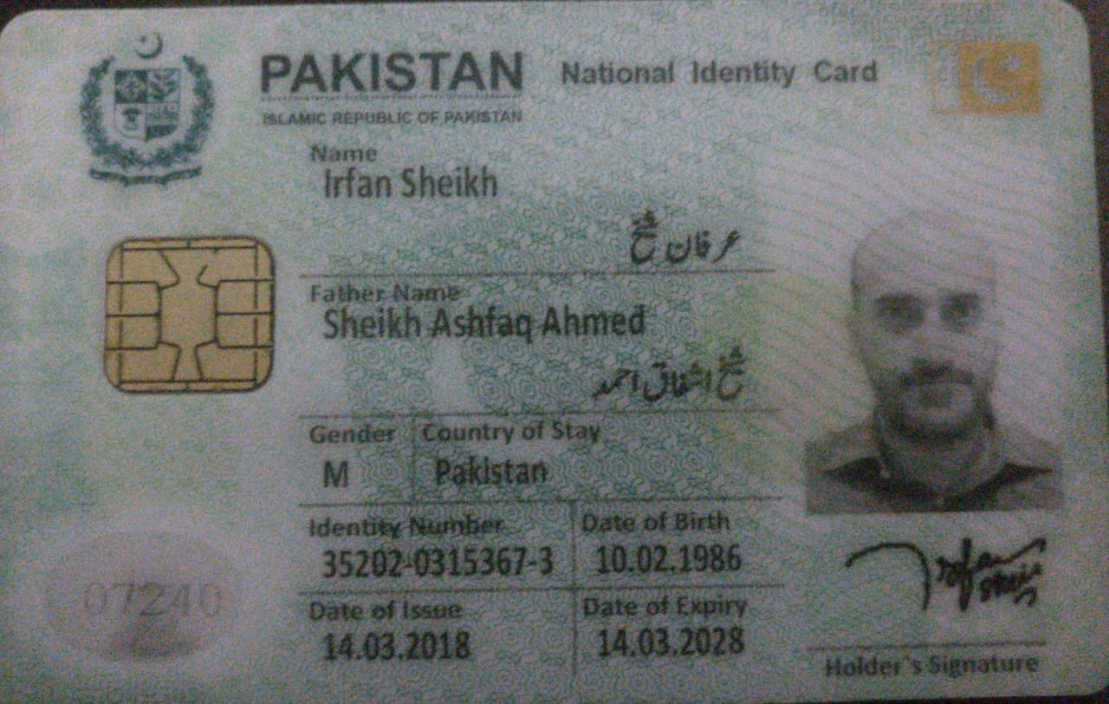

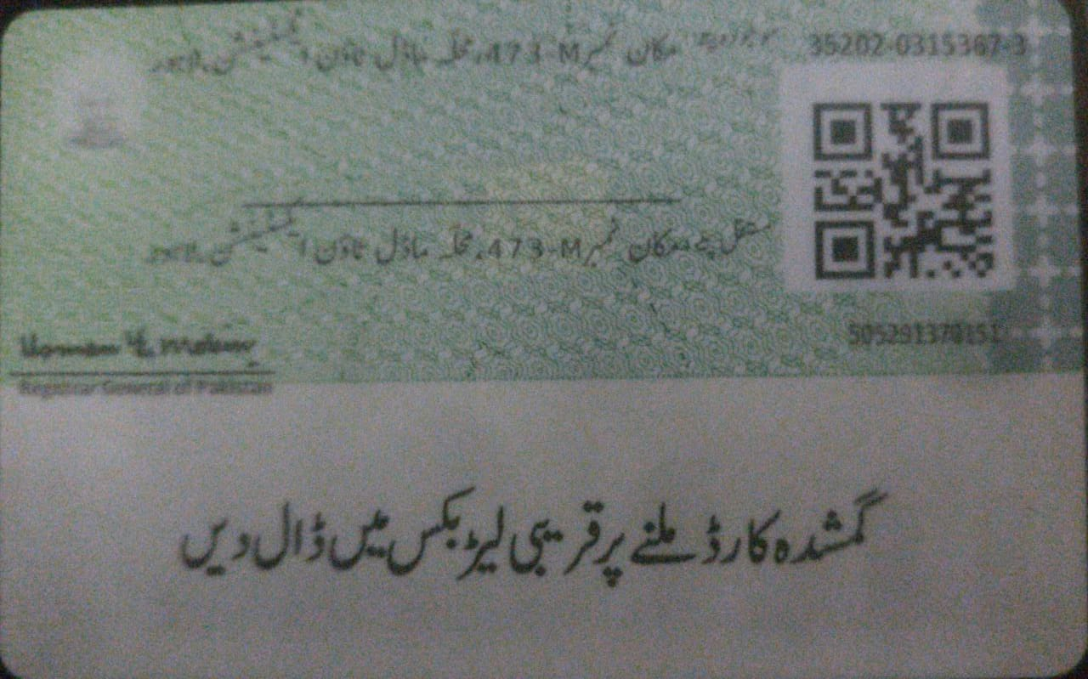



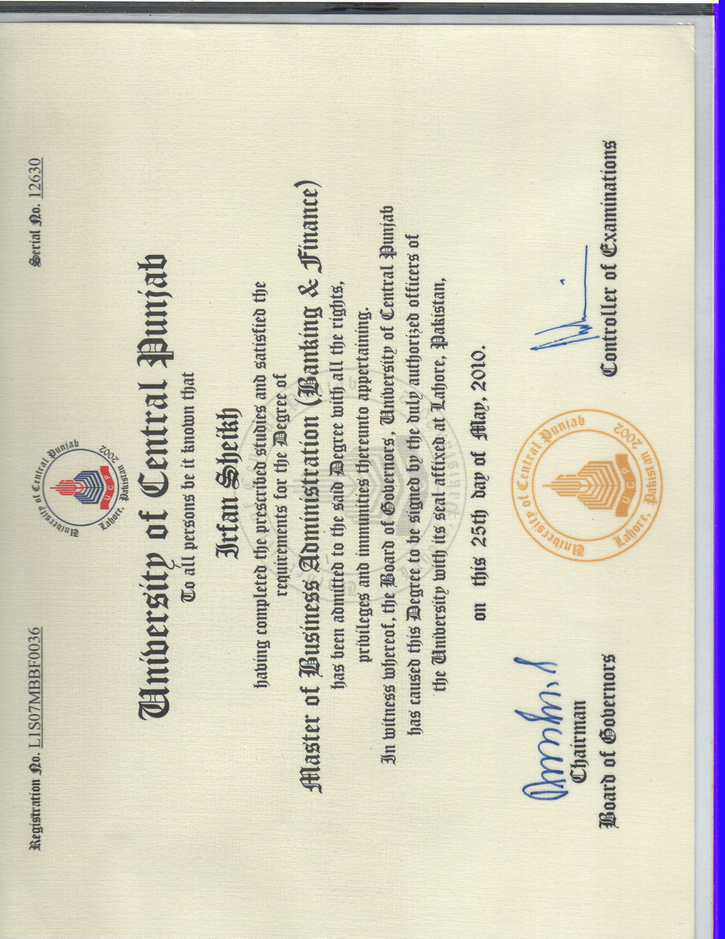

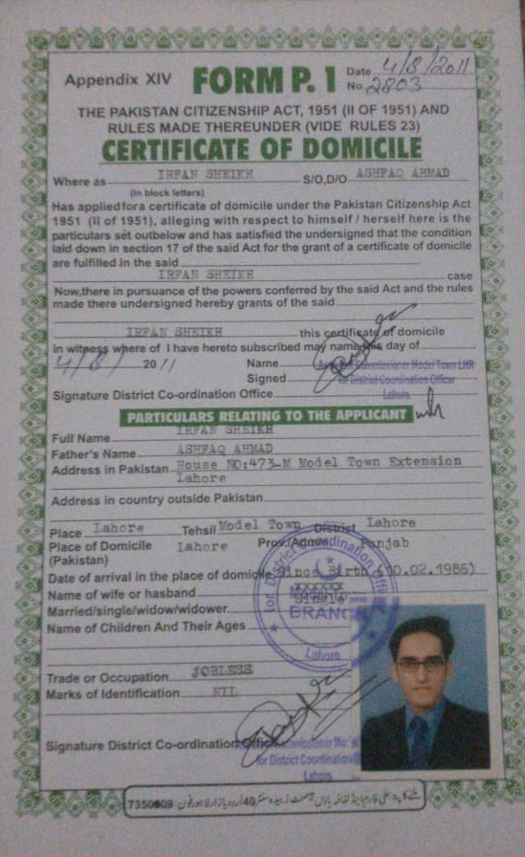

##### Freelance Profile

Full Name :  **IRFAN SHEIKH**

CNIC No.  **35202-0315367-3**

Erozgaar Center :  **UNIVERSITY OF THE PUNJAB , LAHORE**

Course Track :  **TECHNICAL**

##### Freelance Profile Detail

Do you work as a full time Freelancer?*

|  |  |
| --- | --- |
| Yes | No |

Do you work in a team or as an individual freelancer?*

|  |  |
| --- | --- |
| Team | Individual |

Number of active hours spent on freelancing per week *

[0-10hours](javascript:void(0))



Number of projects undertaken till date *

[0-5](javascript:void(0))



Monthly Income *

[5$ TO $100 ( SILVER)](javascript:void(0))



###### **Nature of Work (Please fills the details of course track you choose for training)**

Technical *

|  |  |  |  |  |  |  |  |
| --- | --- | --- | --- | --- | --- | --- | --- |
| WORDPRESS | JAVASCRIPT / FRONT END | PHP | MYSQL | RESPONSIVE HTML | OTHER ( PLEASE SPECIFY ) |  |  |

Other (Please Specify)



**Please Add detail of Plateforms you are working on**  
**(you can also add multiple profile link)**

Freelancer Portal*

[--- Please Select ---](javascript:void(0))



Profile Link*



| [Freelancer Portal](javascript:__doPostBack('ctl00$ContentPlaceHolder1$rdgrdDetail$ctl00$ctl02$ctl01$ctl00','')) | Profile Link | Edit |
| --- | --- | --- |
|  |  |  |
| FIVERR.COM | [View FIVERR.COM](https://www.fiverr.com/users/s4sheikh) |  |

Request to Cancel Previous Enrollment

Your request to cancel previous enrollment has been submitted.  
Please wait for 2-3 working days and then you can register again on [www.erozgaar.pitb.gov.pk](https://www.google.com/url?q=http://www.erozgaar.pitb.gov.pk&sa=D&source=editors&ust=1678405488802789&usg=AOvVaw1gc1cg9nP0A73UVipymhk0)  
Feel free to contact at 04235972099 for any queries or drop your message at [www.m.me/erozgaar](https://www.google.com/url?q=http://www.m.me/erozgaar&sa=D&source=editors&ust=1678405488802880&usg=AOvVaw1Id8axMaruOdAact5swq-2)

[Edit your response](https://docs.google.com/forms/u/0/d/e/1FAIpQLSeZgt0syiD4YV5Ld1tRPJQllDBn3_VeFV4KJdM40ZuBfvNrmw/viewform?usp=form_confirm&edit2=2_ABaOnuc5KVmQQXycUWa6oHLzHAdiz4MW_YgcF42XcRuIj7JOUc9G4Ot5Dj8bKMJQ5A)

This content is neither created nor endorsed by Google. [Report Abuse](https://docs.google.com/forms/u/0/d/e/1FAIpQLSeZgt0syiD4YV5Ld1tRPJQllDBn3_VeFV4KJdM40ZuBfvNrmw/reportabuse) - [Terms of Service](https://policies.google.com/terms) - [Privacy Policy](https://policies.google.com/privacy)

[Forms](https://www.google.com/forms/about/?utm_source=product&utm_medium=forms_logo&utm_campaign=forms)